READ The BIBLE Together

EXODUS Part III

(25:1 – 40:38)

20th December 2015 – 19th March 2016

SHALOM CHURCH, SINGAPORE

(Upholding the 1689 Baptist Confession of Faith)

Week 23 [20th – 26th December 2015]

Days 1- 2 Read EXODUS 25:1-9

Overview of EXODUS 25-40
As we come to EXODUS 25-40, we discover that 'action' has given way to 'instruction'. 'Exciting' events like the crossing of the Red Sea and water flowing from the rock are behind us. What lies ahead are 'less-exciting' instructions on how to construct the Tabernacle. As such, we face the temptation to skip over these 16 chapters rather quickly. However, to do so would be a serious mistake!

EXODUS 25-40 formed 40% of EXODUS. Why would God devote almost half of this book to these 'less-exciting' instructions unless they are actually very important for us to know?

To help us gain a proper orientation of these 16 chapters, we need to note the structure of these 16 chapters:

Chapters 25–31 record the instructions for building the Tabernacle

Chapters 35–40 narrate the actual building of the Tabernacle

Sandwiched between them is the story of the golden calf, a story of rebellion and eventual forgiveness

If not for God's forgiveness, Chapters 35-40 would not even have happened!

Overview of EXODUS 25-31
Two main matters occupy the attention of these 7 chapters: Tabernacle and Priesthood. Both have to do with worship, and they tie in most beautifully with God's declared purpose in bringing Israel out of Egypt:

So He said, “I will certainly be with you. And this shall be a sign to you that I have sent you: When you have brought the people out of Egypt, you shall serve God on this mountain.” (3:12).

A phrase repeats itself seven times in these 7 chapters: Then the LORD spoke/said ... (25:1; 30:11, 17, 22, 34; 31:1). This underlines the fact that these instructions come ultimately from God Himself and not from Moses. In the worship of God, God is the One who has the right to tell us how we must worship Him. We do not turn to our opinions or rely on our wisdom, even if the opinions and wisdom come from a great and holy man like Moses.

Study of EXODUS 25:1-9
1. God wanted the children of Israel to bring Him offerings (verse 1). He gave them a list of things from which they may offer:
gold silver bronze blue thread
purple thread scarlet thread fine linen goats' hair
ram skins dyed red badger skins acacia wood oil spices onyx stones stones for ephod and breastplate

Imagine you were an Israelite then.

(a) What would you offer? Why?

(b) Remember that you were in the wilderness. Where could you get these items for offering?

(c) If you were going to give an offering, how should you do it? (Verse 2)

2. What was the purpose for this offering? (Verse 8)

3. What do you think is the meaning of verse 9?

Note #1: God is going to dwell in the midst of Israel. The Tabernacle is His dwelling place. Hence to have the Tabernacle is their midst is a great blessing for Israel. No other nation on earth has had such privilege!

Note #2: Israel is called upon to participate in the construction of the Tabernacle in two ways:

(a) Contribute the materials needed for the construction
(b) Construct the Tabernacle following the pattern given by God.

God could have just created the Tabernacle and gave it to Israel, but instead God chose to work through His people.

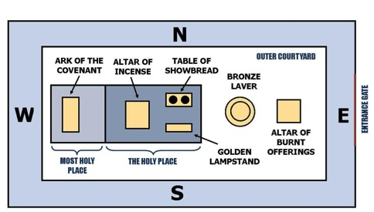

Figure 1: Tabernacle

Days 3 - 4 Read EXODUS 25:10-22

EXODUS 25:10-27:21 contain instructions concerning the construction of the Tabernacle. We would expect God to give the instructions on how to construct the tents first, divide the Tabernacle into Courtyard, Holy Place and Most Holy Place, before talking about the Ark of the Covenant that is to be placed in the Most Holy Place. Yet God started with the Ark of the Covenant, which may strike us as a bit unexpected. Why was it done in this way?

Only one answer will satisfy – it is to stress the importance of the Ark. By placing the Ark first, our attention is drawn to the central concern of the Tabernacle narrative. The Ark is the focus of God’s presence with His people, the central point of contact between heaven and the tabernacle, the earthly symbol of heaven.

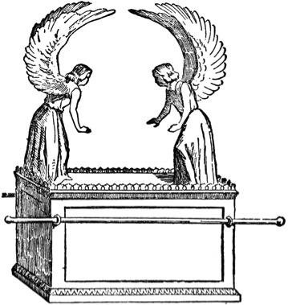 | < ---------- Mercy Seat  < ------------ Ark

Figure 2: Ark of Testimony
The Ark of Testimony has two main parts: Ark and Mercy Seat.

Ark (verses 10-16)

1. What materials were to be used to construct the Ark?

2. At the four corners, we find four rings of gold and two poles placed into the rings. The poles must never be removed.

(a) What was the function of the two poles?

(b) The poles must be in the rings of the ark and never to be taken from it. What do you think is the reason(s) for this arrangement?

Mercy Seat (verses 17-22)

3. (a) What materials were to be used to construct the mercy seat?

(b) Do you think there is any significance in the materials used? Elaborate.

(c) At each end of the mercy seat is a cherub. What is a cherub and where in the Old Testament have we first met with cherubim?

(d) Is there any significance why there is a cherub at the two ends of the Mercy Seat? Elaborate.

4. Below the mercy seat was the ark containing the Testimony given by God (verse 21). What do you think is the Testimony?

5. (a) From where will God speak to Moses/Israel? (Verse 22)

(b) What is the significance of this?

Day 5 Read EXODUS 25:23-30

These eight verses talk about the table of showbread.

1. What materials were used to construct the table?

2. What was to be put on the table?

3. What purpose did the table of showbread serve?

Day 6 Read EXODUS 25:31-40

1. Based on the descriptions given in these ten verses, attempt to sketch the golden lamp-stand in the space below:

Compare your sketch with others from your RTBT group.

2. What do you think is the purpose of the golden lamp-stand?

3. Verse 40 is a repeat of verse 9. Why do you think God must repeat this instruction/warning?

Day 7 Read EXODUS 26:1-37

After reading EXODUS 26 . . .

1. Write down your first impression of this chapter

2. What questions do you have concerning this chapter?

Week 24 [27th December 2015 – 2nd January 2016]

Days 1 - 7 Read EXODUS 26:1-37

EXODUS 26 gives Israel the instructions to construct the Tabernacle (the two portions consisting of the Holy Place and Holy of Holies – see Figure 1 in page 4). The Hebrew word for tabernacle (mishkan) comes from the Hebrew word that means to dwell (shakan). So the Tabernacle was the tent where God will dwell with His people on earth!

Imagine yourself to be an Israelite. Now feel the deep sense of privilege as you hold in your hands EXODUS 26 containing instructions on how to construct the tent where God will dwell with you! How CAREFUL should you read each word and how METICULOUS must you carry out each instruction!

These 37 verses are divided into five sections:

Section 1 -- Inner curtains (verses 1-6)
Ten curtains were to be made, each curtain having a length of 28 cubits and a width of 4 cubits. Five curtains were to be coupled to one another, forming two sets of five curtains. Then via loops of blue yarn and clasps of gold, the two sets of curtains were to be joined together to form one tabernacle.

1. (a) What material was to be used to make the curtains?

(b) Do you think there is any significance in this? Elaborate.

2. (a) What figures can you see on the curtains?

(b) What is the significance in this?

Section 2 – Outer curtains (verses 7-14)
Altogether, there were three sets of outer curtains to protect the inner curtains from the elements.

- The first set of outer curtains were made of ______________________ (verse 7)

- The second set of outer curtains were made of ______________________ (verse 14)

- The third set of outer curtains were made of ______________________ (verse 14)

As a result of these three outer curtains, the Tabernacle would be very dark inside. So how would the priest find his way inside the Tabernacle?

Section 3 – Framework (verses 15-30)
These 16 verses describe the wooden frame to be constructed that the four curtains are to be draped over:
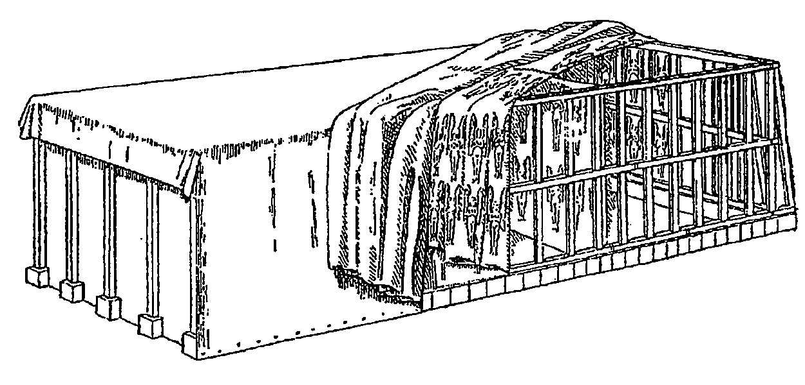
Figure 3: Tabernacle framework

The tabernacle frame and base would look something like this:

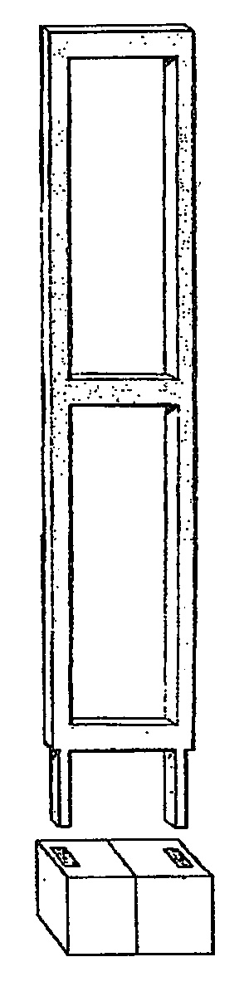
Figure 4: Tabernacle frame and base

Section 4 – Veil (verses 31-35)

1. What material was to be used to make the veil?

2. What figures can you see on the veil?

3. What was the purpose of this veil?

Note: Verses 34-35 give instructions on where to place the various piece of furniture in the Tabernacle. Read these two verses together with Figure 1 in page 4.

Section 5 – Entrance (verses 36-37)
The entrance to the Tabernacle was a curtain of _____________, _______________ and _____________ thread, and fine woven __________________.

Lessons from EXODUS 26
Let’s imagine that as Israelites, we have followed the instructions given and set up the Tabernacle. What are we supposed to see and learn?

(1) God dwells among us!
We have already heard God said in EXODUS 25:8 that we are to make Him a sanctuary and He will dwell among us. Heaven is where God is! So when God comes to live with us, He brings heaven down with Him, for the Tabernacle is a piece of Heaven on earth.

The Ark of the Covenant placed inside the Holy of Holies represents God’s throne. The figures on its cover represent the angels who stand guard in the throne room of Heaven. There are more cherubim on the curtains of the Tabernacle and the veil that separates the Holy Place and the Holy of Holies. So when the High Priest enters the Holy of Holies (God’s sanctuary on earth), he catches a glimpse of Heaven, where God sits enthroned above the cherubim.

“The tabernacle was a microcosm of the universe. Inside was Heaven, and outside was earth, with God at the center of it all. The heart of the tabernacle was the Holy of Holies, where God reigned in glory. The tabernacle, in turn, was at the heart of Israel, with all twelve tribes surrounding it. And Israel was the heart of the world, the centerpiece in God’s plan for saving the nations. The tabernacle was the most important place in the world, a little bit of Heaven on earth. The point was not that somehow God could be contained within the four walls of a tent. No; the tabernacle was set up like Heaven to show that God rules over both Heaven and earth.”
Philip Graham Ryken

(2) We cannot go near to God!
Although the Tabernacle is right in our midst, yet most of us were never allowed to go inside. We can see it from a distance, and we know that God had His dwelling there, but we never even have a chance to see past the door, let alone go inside and meet with God. Everything was concealed under layers of fabric.

The priests alone can enter the Tabernacle, and only when they have some priestly duty to perform. As they enter the Holy Place, before long the veil confronts them. This veil will stop them from going into the Holy of Holies where God’s throne is located!

Then there are the pictures of the cherubim – on the inner curtains and the veil. Looking at the cherubim, we are reminded of GENESIS 3:24 ~ So He drove out the man; and He placed cherubim at the east of the garden of Eden, and a flaming sword which turned every way, to guard the way to the tree of life.

These cherubim blocked the entrance back to Eden. The cherubim (on the tapestries in the tabernacle) represent something similar. In a symbolic manner, they guard the way to God.
“Though Israel had this tremendous privilege of the divine presence in their midst, there was to be no doubt that he is the Holy One, and that access to him was no easy matter, even though his palace and temple was right there at the centre of their camp.”
John Mackay

(3) We can only draw near via priests and blood!
There is an entrance into the tabernacle (recall Section 5 above). As we shall learn soon, only the priests can enter the Holy Place, and only the High Priest can enter the Holy of Holies once a year. And they can only enter the Tabernacle carrying an atoning sacrifice for sin — their sins as well as the sins of the people they represent.

This was the only way. The tabernacle does not have a back door. The only way for unholy sinners to enter the presence of a holy God is by means of a blood sacrifice and through priests representing them.

Ponder and answer: How can we see the Gospel in EXODUS 26?

[Use these verses to help you frame your answer if needed: PSALM 15, JOHN 1:14, 14:6, MARK 15:37-38, HEBREWS 9:12, 24; 10:19-20]

Week 25 [3rd -9th January 2016]

Days 1 - 4 Read EXODUS 27:1-8 (Altar of Burnt Offering)

1. The Altar of the Burnt Offering, made of acacia wood, is five cubits long, five cubits wide and three cubits high.

(a) Refer to Figure 1 in page 4. Where should this altar be placed in the Tabernacle?

(b) Why do you think it is placed here?

2. This was the first piece of Tabernacle furniture that had bronze overlay instead of gold (verse 2). Although it had a bronze overlay, the basic material used to construct this altar was acacia wood.

Since the altar was used to burn the sacrifices, and wood is easily combustible, wouldn’t this create a problem? Discuss with your RTBT Group.

3. What do you think the horns (verse 2) were for?

4. From verse 8a, we know that the altar of burnt offering was hollow inside. Why?

Here’s a possible reason given by Philip Graham Ryken: “In other words, it was an empty frame. The four sides of the altar were solid, but there was nothing inside except the grate. This helps us reconcile the instructions given here with God’s prior command to make his altar out of earth and stone (Exod 20:24, 25). Since it was hollow, the bronze altar allowed the Israelites to keep this commandment. Whenever they traveled to a new place, they set up the frame and then built an altar of earth and stone inside.”

5. In verse 8, God again repeated His warning: As it was shown to you on the mountain, so shall they make it. Why do you think God repeated this warning so often?

6. How can we see the Gospel from these 8 verses?

Notice the place where this altar is located in the Tabernacle and recall the purpose of this altar.

The Tabernacle is the dwelling place of God on earth. As you seek to draw near to Him, the first thing you meet, after you pass the entrance of the Tabernacle, is the altar of burnt offering.

What is this altar for? This is where animals are slain and burnt as sacrifices, and its blood smeared on the horns of the altar.

This tells us that unless life is taken and blood shed, we cannot draw near to God. This tells us that we are sinners, and every time we want to approach God, we must come through this altar.

Jesus is our altar. He was slain, His blood was shed, and He is our sacrifice. There is no way we can draw near to God until our sins have been dealt with effectively. The first thing we need is the forgiveness of our sins, and we have forgiveness only in Jesus. “Him God has exalted to His right hand to be Prince and Savior, to give repentance to Israel and forgiveness of sins.” (ACTS 5:31)

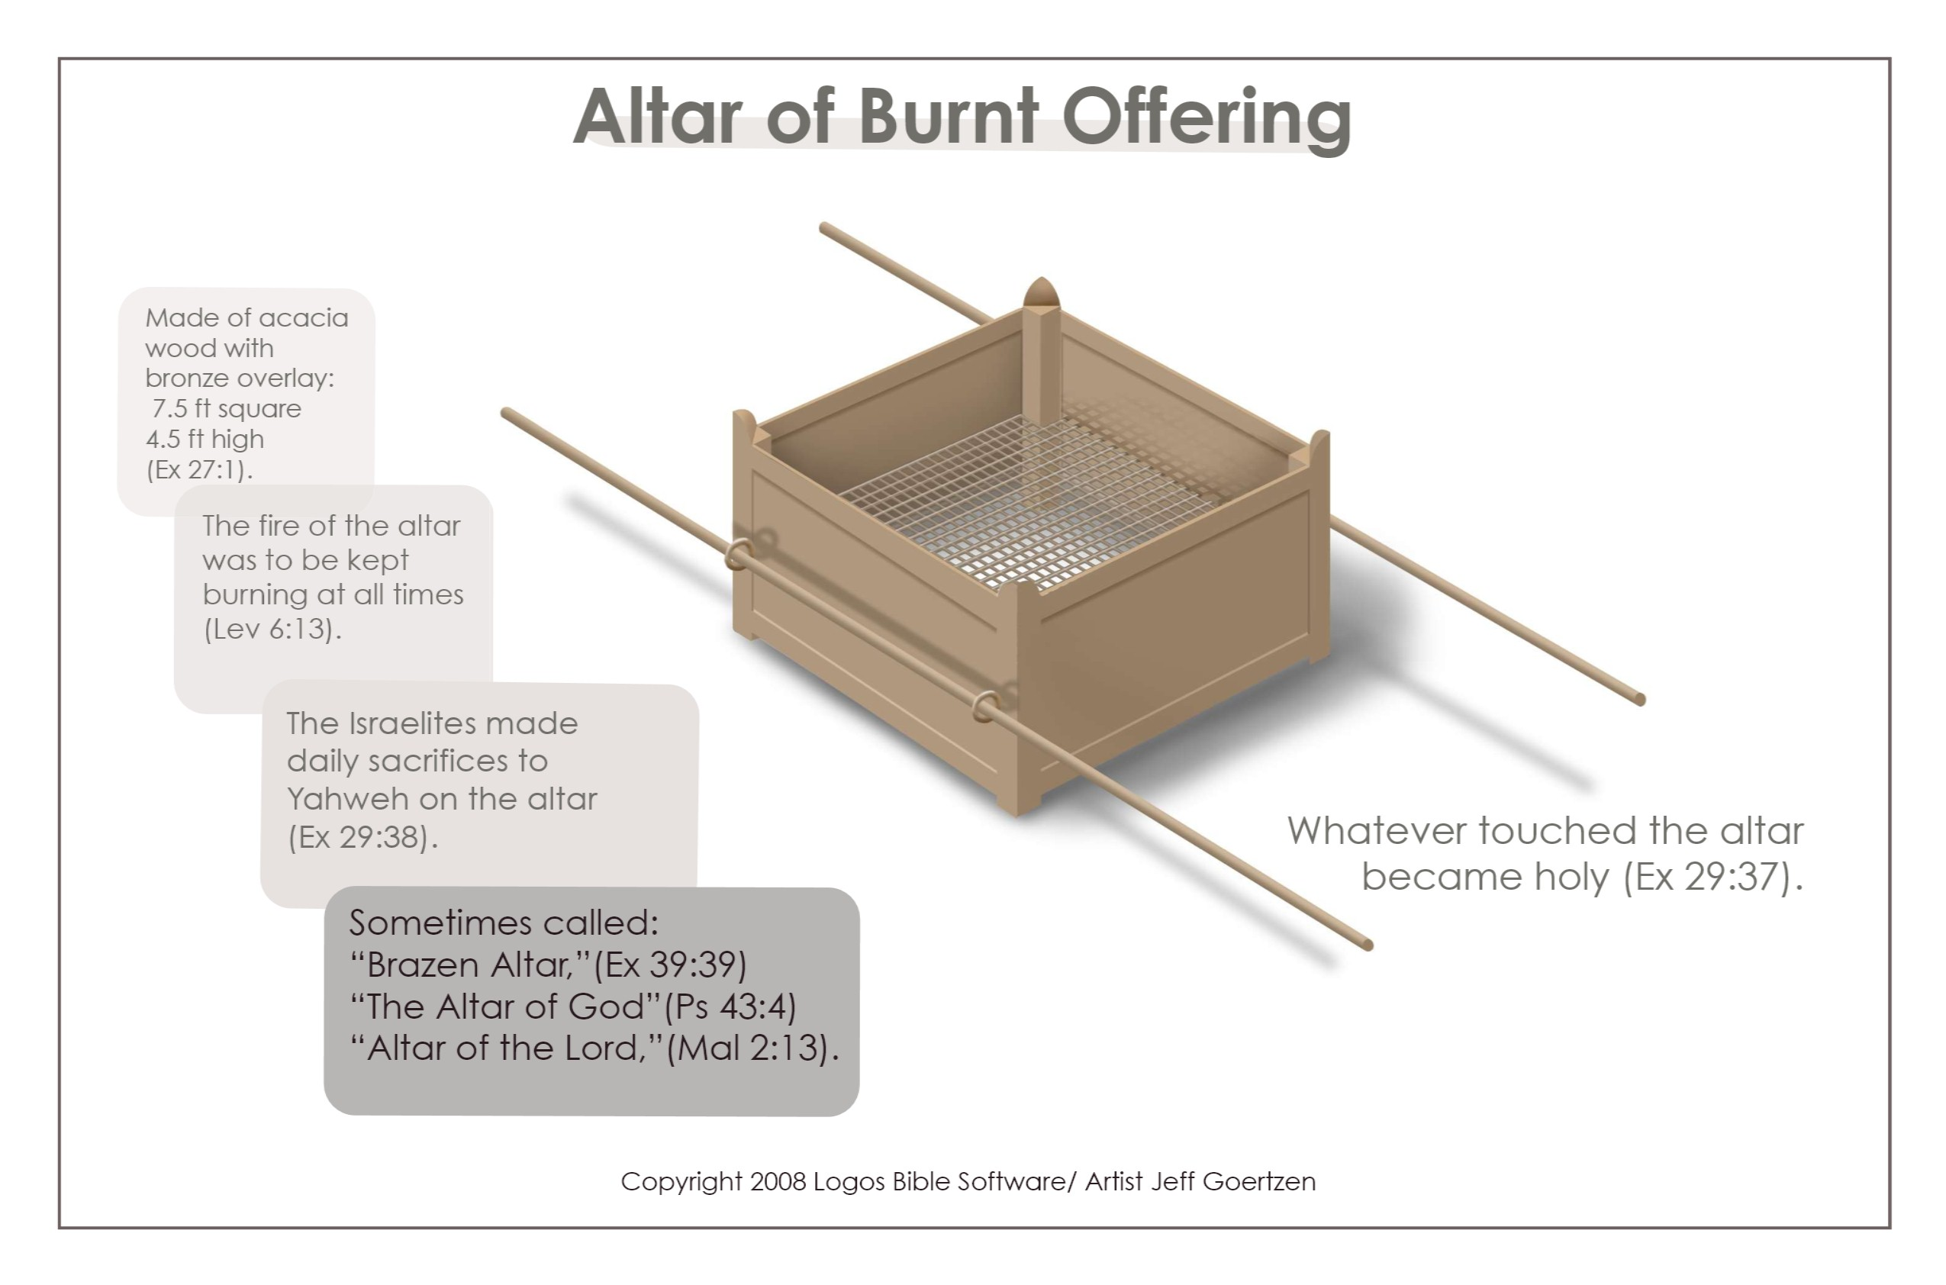
Figure 5: Altar of Burnt Offering

Day 5 Read EXODUS 27:9-19

After reading EXODUS 27:9-19, go on to read the comments on this passage by Matthew Henry:

Before the tabernacle there was to be a court or yard, enclosed with hangings of the finest linen that was used for tents. This court, according to the common computation of cubits, was fifty yards long, and twenty-five broad. Pillars were set up at convenient distances, in sockets of brass, the pillars filleted with silver, and silver tenter-hooks in them, on which the linen hangings were fastened: the hanging which served for the gate was finer than the rest, v. 16.

This court was a type of the church, enclosed and distinguished from the rest of the world, the enclosure supported by pillars, denoting the stability of the church, hung with the clean linen, which is said to be the righteousness of saints, Rev. 19:8 .

These were the courts David longed for and coveted to reside in (Ps. 84:2, Ps. 84:10 ), and into which the people of God entered with praise and thanksgiving (Ps. 100:4 ); yet this court would contain but a few worshippers. Thanks be to God, now, under the gospel, the enclosure is taken down. God’s will is that men pray everywhere; and there is room for all that in every place call on the name of Jesus Christ.

After reading Matthew Henry’s comment . . .

1. What questions do you have?

2. What lessons have you learnt?

Day 6 Read EXODUS 27:20-21

After reading EXODUS 27:20-21, go on to read the comments on this passage by Matthew Henry:

We read of the candlestick in the twenty-fifth chapter; here is an order given for the keeping of the lamps constantly burning in it, else it was useless; in every candlestick there should be a burning and shining light; candlesticks without candles are as wells without water or as clouds without rain.

Now (1): The people were to provide the oil; from them the Lord’s ministers must have their maintenance. Or, rather, the pure oil signified the gifts and graces of the Spirit, which are communicated to all believers from Christ the good olive, of whose fulness we receive (Zec. 4:11, Zec. 4:12 ), and without which our light cannot shine before men.

(2): The priests were to light the lamps, and to tend them; it was part of their daily service to cause the lamp to burn always, night and day; thus it is the work of ministers, by the preaching and expounding of the scriptures (which are as a lamp), to enlighten the church, God’s tabernacle upon the earth, and to direct the spiritual priests in his service. This is to be a statute for ever, that the lamps of the word be lighted as duly as the incense of prayer and praise is offered.

After reading Matthew Henry’s comment . . .

1. What questions do you have?

2. What lessons have you learnt?

Day 7 Read EXODUS 28:1-43

After reading these 43 verses, write down . . .

1. Your first impressions of this passage

2. Any questions you might have concerning this passage

We will go into the details of these 43 verses in Week 26. Meanwhile, take some time to look at an artist sketch of the High Priest vestments in page 16.
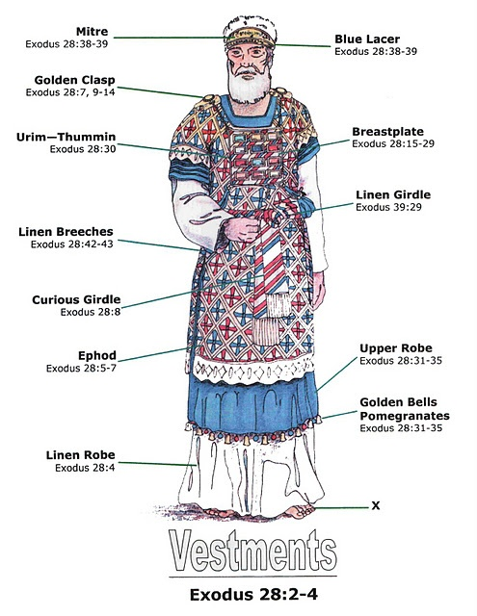

Figure 6: Vestments for High Priest

Week 26 [10th - 16th January 2016]

Day 1 Read EXODUS 28:1-4

1. Who chose Aaron and his sons (Nadab, Abihu, Eleazar and Ithamar) to serve as priests?

2. (a) What were the various pieces of the priestly garments?

(b) What three words were used to describe the priestly garments?

- Holy (verse 2)

(c) Why do you think the priests were dressed so splendidly when they serve?

Day 2 Read EXODUS 28:5-14

1. These 10 verses talk about the Ephod (see Figure 6 in page 16).

(a) What materials were used to make the Ephod?

- Fine linen (verse 5)

- Scarlet thread (verse 5)

(b) The materials used to make the Ephod were the same materials used to make the Tabernacle. What do you think is the significance of this?

2. Two onyx stones in settings of gold were to be put on the shoulders of the Ephod.

(a) What was engraved on the onyx stones?

(b) What do you think is the significance of this?

Days 3 - 4 Read EXODUS 28:15-30

1. These 16 verses talk about the Breastplate (see Figure 6 in page 16).

What materials were used to make the Breastplate?

- Fine linen (verse 15)

- Scarlet thread (verse 5)

2. (a) Placed on the Breastplate are twelve precious stones, in three rows of four:

First row:

Second row:

Third row:

Fourth row:

(b) What was engraved on each of the precious stone?

(c) What do you think is the significance of this?

3. The Urim and the Thummim were to be put inside the Breastplate (verse 30). Other parts of the Old Testament gave us examples of how they were used:

- NUMBERS 27:21

- I SAMUEL 28:6

- I SAMUEL 30:7-8

- EZRA 2:62-63
NEHEMIAH 7:64-65

Clearly, this was how God gave Israel guidance in perplexing matters. How does God give us guidance today?

Days 5 - 6 Read EXODUS 28:31-39

1. Verses 31-35 talk about the Robe to be worn by the priest.

(a) What was the color of the Robe?

(b) What two things must be woven into the hem of the Robe?

(c) Why must (b) be done?

2. Verses 39 mentioned three other pieces of the priestly garments. What were they?

3. Verses 36-38 talked about a plate of pure gold to be placed on the turban. What was engraved on it?

4. Concerning this plate of pure gold, this is what Matthew Henry said:

“Concerning the golden plate fixed upon Aaron’s forehead, on which must be engraven, Holiness to the Lord (v. 36, v. 37), or The holiness of Jehovah. Aaron must hereby be reminded that God is holy, and that his priests must be holy. Holiness becomes his house and household. The high priest must be sequestered from all pollution, and consecrated to God and to his service and honour, and so must all his ministrations be. All that attend in God’s house must have Holiness to the Lord engraven upon their foreheads, that is, they must be holy, devoted to the Lord, and designing his glory in all they do.

This must appear in their forehead, in an open profession of their relation to God, as those that are not ashamed to own it, and in a conversation in the world answerable to it.

It must likewise be engraven like the engravings of a signet, so deep, so durable, not painted to be washed off, but sincere and lasting; such must our holiness to the Lord be. Aaron must have this upon his forehead, that he may bear the iniquity of the holy things (v. 38), and that they may be accepted before the Lord.

Herein he was a type of Christ, the great Mediator between God and man, through whom it is that we have to do with God.

(1.) Through him what is amiss in our services is pardoned. The divine law is strict; in many things we come short of our duty, so that we cannot but be conscious to ourselves of much iniquity cleaving even to our holy things; when we would do good evil is present; even this would be our ruin if God should enter into judgment with us. But Christ, our high priest, bears this iniquity, bears it for us so as to bear it from us, and through him it is forgiven to us and not laid to our charge.

(2.) Through him what is good is accepted; our persons, our performances, are pleasing to God upon the account of Christ’s intercession, and not otherwise, 1 Pt. 2:5 . His being holiness to the Lord recommends all those to the divine favour that are interested in his righteousness, and clothed with his Spirit; and therefore he has said it was for our sakes that he sanctified himself, Jn. 17:19 . Having such a high priest, we come boldly to the throne of grace, Heb. 4:14-16.”

After reading Matthew Henry’s comment . . .

(a) What questions do you have?

(b) What lessons have you learnt?

Day 7 Read EXODUS 28:40-43

These 4 verses talk about the garments to be worn by Aaron’s sons as they serve in the Tabernacle. Their garments were clearly simpler than Aaron’s. Hence we know that what was described from verses 5-39 was only meant for Aaron as he served as High Priest.

1. Tunics, sashes and hats were made for the priests to wear.

(a) Something else was to be made and worn by the priest. What was it? (Verse 42)

(b) What would happen to the priests if they did not wear this piece of garment? (Verse 43)

2. What is the purpose for dressing the priests in this way? (Verse 40)

- How can you see the Gospel in EXODUS 28?

4. What lessons have you learnt from EXODUS 28 for your Christian Life?

Week 27 [17th – 23rd January 2016]

Days 1 - 3 Read EXODUS 29:1-37

These 37 verses concern the consecration of the priests. What questions do you have after reading these 37 verses?

Focusing on verses 1-3 . . .

1. “And this is what you shall do to them to hallow them for ministering to Me as priests” (verse 1).

(a) Who is “Me”?

(b) Who is “you”?

(c) Who is “them”?

(d) What does “hallow” mean?

Note #1: It is clear that the priests were not self-appointed, but divinely appointed.

Note #2: It is clear that, whatever business is required to be carried out at the Tabernacle, it was not to be done via ‘self-service’! The Israelites needed a group of selected men to do the business on their behalf.

2. Verse 2 tells us the materials that Moses had to get ready for the consecration of the priests. What were they?

- One young bull without blemish

- Unleavened cakes mixed with oil

Focusing on verses 4-9 . . .

These 6 verses describe for us the first three steps needed in the consecration of the priest.

1. (a) What was the first step? (Verse 4)

(b) What do you think this first step symbolize?

2. (a) What was the second step? (Verses 5-6, 8-9)

(b) What do you think this second step symbolize?

3. (a) What was the third step? (Verse 7)

(b) What do you think this third step symbolize?

(b) Do you think this third step was done only for Aaron, or for both Aaron and his sons? Elaborate.

Days 4 - 7 Read EXODUS 29:1-37

Focus on verses 10-14 that tell us the fourth step needed in the consecration of the priest. It involved a sin offering . . .

1. What must Aaron and his sons do?

2. What is the significance of killing the bull?

3. (a) What must be done with the blood of the bull?

(b) What do you think is the significance of this action?

3. Which part of the bull must be burnt on the altar and which parts must be burnt outside the camp?

4. Throughout these 5 verses, the pronoun “you” appeared many times – the person who was to carry out this sin offering.

(a) Who is the “you”?

(b) What is the significance that the priests need “you” to do this act for them?

Focus on verses 15-18 that tell us the fifth step needed in the consecration of the priest. It involved a burnt offering . . .

1. What was to be done with the blood of the ram?

2. What was to be done with the rest of the ram?

3. (a) Before the ram was killed, what must Aaron and his sons do?

(b) What do you think is the meaning of this action?

Focus on verses 19-28 that tell us the sixth step needed in the consecration of the priest. It involved the offering of a heave offering . . .

1. The ram involved is called the ram of consecration (verse 22). After Aaron and his sons had laid their hands on it, it was to be killed.

(a) What was to be done with the blood of this ram?

Verse 20:

Verse 21:

(b) What was the result of (a) upon the priests?

2. Within this heave offering, there was a burnt offering (verses 22-25).

(a) What was to be burnt?

(b) What do you think is the significance of burning those parts from the ram?

3. In the offering of a heave offering, the priests shall receive the breast and the thigh of the animal. This is what verses 27-28 are saying. However, in this “consecration of priests” ritual whereby a heave offering was offered, a special arrangement was done:

(a) Moses, acting as a priest in consecrating these priests, shall receive the breast of the ram (verse 26).

(b) The thigh of the ram was already included in the burnt offering (verse 22) offered to the Lord.

(c) The Easton’s Bible Dictionary explains ‘heave offering’ as follows:

Hebrew terumah (Ex. 29:27) means simply an offering, a present, including all the offerings made by the Israelites as a present. This Hebrew word is frequently employed. Some of the rabbis attach to the word the meaning of elevation, and refer it to the heave offering, which consisted in presenting the offering by a motion up and down, distinguished from the wave offering, which consisted in a repeated movement in a horizontal direction, a "wave offering to the Lord as ruler of earth, a heave offering to the Lord as ruler of heaven." The right shoulder, which fell to the priests in presenting thank offerings, was called the heave shoulder (Lev. 7:34; Num. 6:20). The first fruits offered in harvest-time (Num. 15:20, 21) were heave offerings.

Week 28 [24th – 30th January 2016]

Days 1 - 2 Read EXODUS 29:1-37

Focus on verses 29-35 that tell us the seventh step needed in the consecration of the priest, is a fellowship meal . . .

1. We read of the fellowship meal in verses 31-34.

(a) What would the priests eat? (Verse 32)

(b) Where would the priests eat? (Verse 32)

(c) How should the priests treat any leftovers? (Verse 34)

(d) What do you think is the significance of this fellowship meal?

2. Verse 37 says that the priests were to be consecrated for seven days.

(a) What must be done for each of these seven days?

(b) What do you think is the significance that seven days were needed to consecrate the priests?

Day 3 Read EXODUS 29:38-42

“The situation that will prevail after the priests had been duly installed is now envisaged, and details are given of the regular offerings they are to present.” (John L. Mackay)

1. What must be offered in the tabernacle every day?

2. At what time of the day must the burnt offering be offered?

3. What is the relevance of these five verses for us today?

Day 4 Read EXODUS 29:43-46

What do you think is the message of these four verses?

Day 5 Review EXODUS 29

1. How can we see the Gospel in EXODUS 29?

2. What lessons for the Christian Life have you learnt from EXODUS 29?

Days 6 - 7 Read EXODUS 30:1-10, 34-38

What materials were used to make the altar of incense, where was it to be placed and what purpose did it serve? (EXODUS 30:1-10)

What materials were used to make the incense and what warning was given concerning it? (EXODUS 30:34-38)

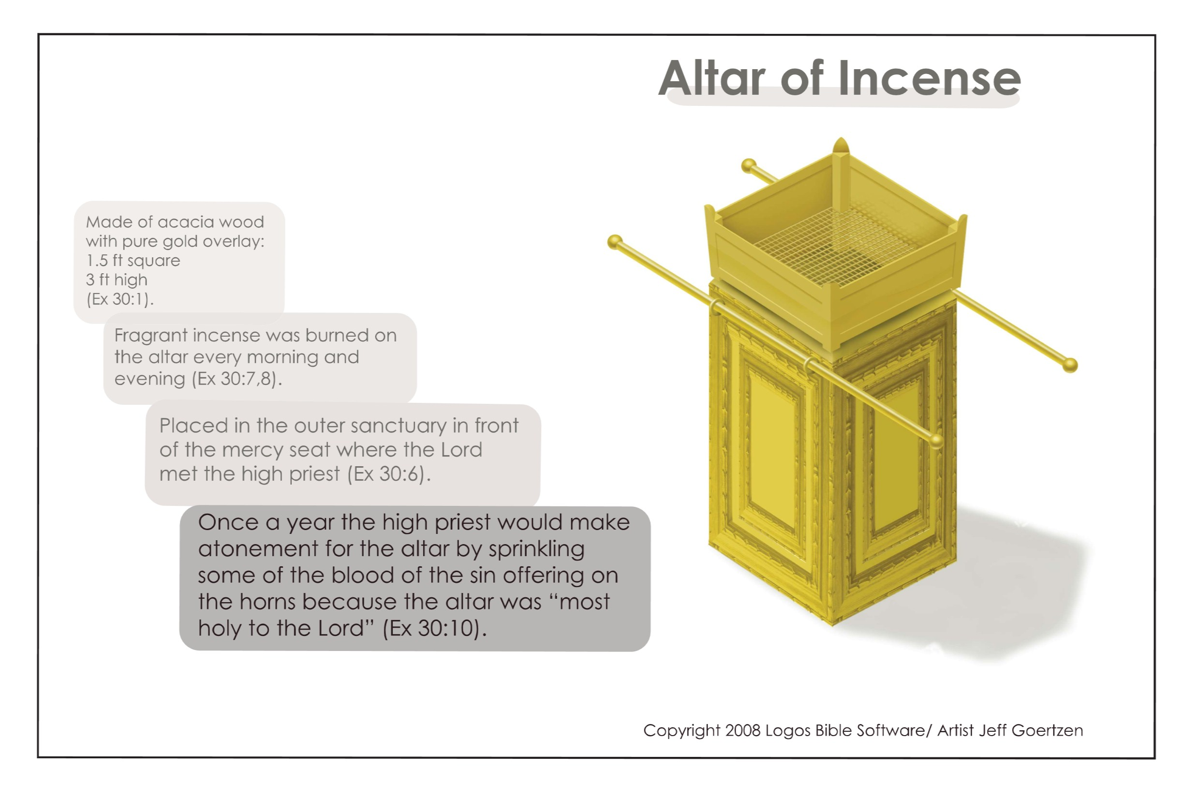
Figure 7: Altar of Incense
Some Notes on the Altar of Incense
What does the altar of incense symbolize?

PSALM 141:1-2 read:

Lord, I cry out to You;
Make haste to me!
Give ear to my voice when I cry out to You.
Let my prayer be set before You as incense,
The lifting up of my hands as the evening sacrifice.

The psalmist David was referring to the daily ritual for worship in the Tabernacle whereby the priest would burn incense before the Lord. As David cried out for help, he asked God to receive his prayers like how He received the incense offered by the priest in the Tabernacle. It seems clear that altar of incense, especially the incense being burnt, is a symbol of prayer.

Another passage connecting incense to prayer is in the LUKE 1:8-11.

So it was, that while he was serving as priest before God in the order of his division, according to the custom of the priesthood,
his lot fell to burn incense when he went into the temple of the Lord.
And the whole multitude of the people was praying outside at the hour of incense.
Then an angel of the Lord appeared to him,
standing on the right side of the altar of incense.

In the providence of God, it was Zechariah’s turn (serving as priest) to burn incense on the golden altar. As he prepared to make his offering, a crowd of people gathered outside to pray. This happened at the temple every day, morning and evening. At the same time that incense was offered in the Holy Place, people met for prayer out in the courtyard. Thus, it appears that the time for offering incense was a time for intercession. As the people prayed, and as the priest prayed for the people, the incense symbolized their prayers ascended to the throne of God.

The same message comes through in REVELATION. In 5:8, we read:

Now when He had taken the scroll,
the four living creatures and the twenty-four elders fell down before the Lamb,
each having a harp, and golden bowls full of incense,
which are the prayers of the saints.

In REVELATION 8:3-4, we read:

Then another angel, having a golden censer, came and stood at the altar.
He was given much incense,
that he should offer it with the prayers of all the saints upon the golden altar which was before the throne.
And the smoke of the incense, with the prayers of the saints,
ascended before God from the angel’s hand.

The incense symbolized the prayers of God’s people. Coming back to EXODUS 30:7-8, we are told that the priest must burn the incense in the morning and in the evening. And in EXODUS 30:10, we are told that the blood of the sin offering would make atonement for the altar of incense.

Applying this to Christ our High Priest, this tells us that as our High Priest, He intercedes for us day and night (that is, ceaselessly) and His prayer for us in heaven is based on His death for us on the cross!

Applying this to Christians who, in Christ, are a holy priesthood, this tells us that we must pray without ceasing, and that we can pray to God because Jesus has become our sin offering to make atonement for us!

Week 29 [31st January – 6th February 2016]

Days 1 - 2 Read EXODUS 30:11-16

1. It is assumed that Israel would conduct regular census, for verse 11 says, “WHEN you take the census for the children of Israel for their number . . .”

(a) Who would be included in this census taking? (Verse 14)

(b) What must be done during the census? (Verse 12)

(c) What would happen if (b) is not done? (Verse 12)

2. Take some time to read the comments of Philip Ryken on this matter:

“The Hebrew word translated ‘to count’ or ‘to number’ has military connotations. It means ‘to muster for battle.’ Significantly, the only people counted were males twenty years old and up (Exod. 30:14). In other words, the Israelites were counting men old enough to fight . . . The military context of census-taking is also confirmed in the book of Numbers, where God says to Moses, ‘You and Aaron are to number by their divisions all the men in Israel twenty years old or more who are able to serve in the army’ (1:3). As the Israelites prepared for battle, they numbered their troops.

All of this raises an obvious question: Why was it so dangerous to take a census? To understand Israel’s peril, it helps to understand that numbering things is an act of authority. Who has the right to take inventory? Only the person who owns whatever is being counted. We only have the authority to count things that are rightfully ours. We can’t put our numbers on other people’s stuff. So who had the right to number the Israelites? Only God. They were his people; so he alone had the authority to count them. A. W. Pink comments: ‘When God numbers or orders anything to be numbered, taking the sum of them denotes that they belong to Him, and that He has the sovereign right to do with them as He pleases. The action itself says of the things numbered: These are Mine, and I assign them their place as I will.’

Therefore, the only proper way to count the Israelites was for the glory of God alone. Whenever the Israelites took a census, they were in serious danger of forgetting this. After all, they were the ones doing the counting. Thus they would be tempted to think that their great numbers were a credit to them rather than to God. And although it was not a sin to take a census, it was a sin to rob God of his glory.”

The payment of this price did not atone for sin. As we have seen throughout Exodus, atonement for sin only comes through a sacrifice of blood. Everyone in Israel had already received atonement through the sin offering made on the altar of sacrifice. Salvation from sin is always a free gift of God’s grace — a gift that comes ‘without money and without cost’ (Isa. 55:1b). There is no payment we can make for our sins. Nevertheless, the ransom paid during the census was called ‘the atonement money.’ And although it did not atone for the people’s sins, according to God it ‘made atonement for their lives.’ It rescued them from the particular punishment of the plague, reminding them that they belonged to God and not to themselves.

Jesus paid the same price for all of us, showing that we are all of equal worth to God. The ransom price for the census made a powerful statement about this. God said to Moses, ‘The rich are not to give more than a half shekel and the poor are not to give less when you make the offering to the LORD to atone for your lives’ (Exod. 30:15). Every Israelite was equal in the sight of God. Whether he was rich or poor, each man had to pay the same half shekel. No one was worth any more or any less than anyone else. Everyone stood before God on equal terms.”

After reading the comments by Philip Ryken above, what questions do you have and what lessons have you learnt?

Day 3 Read EXODUS 30:17-21

These five verses talk about the Bronze Laver . . .

1. What materials were used to make it?

2. Where was it to be placed?

3. We have read in 29:4 that the priests were washed at their consecration. Why then must they be washed again using this Bronze Laver (verses 20-21) lest they die?

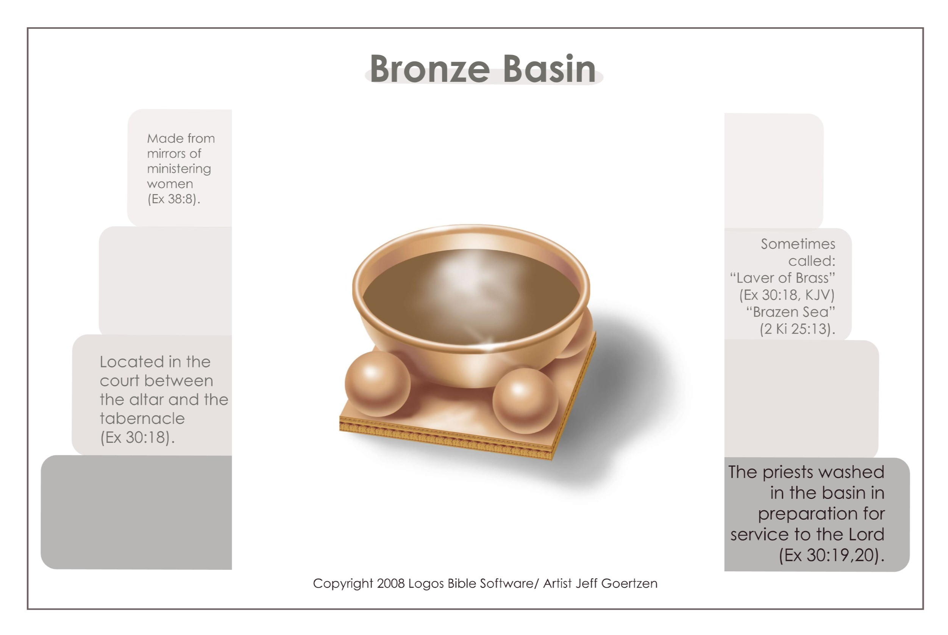
Figure 8: Bronze Laver (Basin)

Day 4 Read EXODUS 30:22-33

These twelve verses talk about the holy anointing oil . . .

1. What materials were used to make it?

2. How was it supposed to be used?

3. What warning was given concerning it?

Day 5 Read EXODUS 31:1-11

In these 11 verses, we meet the artisans involved in the construction of the Tabernacle, in particular Bezalel the chief artisan and Aholiab his top assistant.

1. Who was Bezalel? (Verse 2)

2. Who was Aholiab (Verse 6)

3. What were they supposed to do? (Verses 4-5, 7-11)

4. What would enable them to accomplish their task? (Verse 3, 6)

5. In carrying out their work, how much room was there for the artisans to use their own creativity and imagination? Discuss with your RTBT Group.

Note #1: Although Moses was given the instructions on how to construct the Tabernacle, yet he was not the one to construct it. Instead, Bezalel and Oholiab were the ones to do the job. Why? This is because it wasn’t his gift! Moses was a prophet, but the Tabernacle needed an artist. In order to fulfill its divine function, God’s holy dwelling had to be made by the best artisans, as well as with the finest materials.

Note #2: God called Bezalel and Oholiab to do the task. They were not selected by a jury of fellow artists but were appointed by the sovereign and electing choice of God. Bezalel and Oholiab were not just called — they were also gifted. See EXODUS 31:3. Neither Bezalel nor Oholiab had ever built a tabernacle before. Nevertheless, God called them to build it, and when He called them, He also equipped them. Their example shows that God will equip us to do whatever He calls us to do.

Days 6 - 7 Read EXODUS 31:12-18

This is the fourth time in EXODUS that Sabbath is mentioned. Previously, we find Sabbath mentioned in:

- 16:23

- 20:8-11

- 23:12

Sabbath will be mentioned again, for the fifth time, in 35:1-3.

The mere fact that Sabbath is mentioned a total of five times in EXODUS must underline to us the fact that it is an important matter!

From EXODUS 25:1 onwards, God has given Israel instructions via Moses regarding the construction of the Tabernacle. As we come to the last section of these instructions, we find God repeating His instructions concerning the Sabbath. Why?

Two possible reasons:

[1] The construction of the Tabernacle is meaningless without the keeping of the Sabbath!

The Tabernacle was God’s dwelling place with man on earth. But what is the point of having a meeting place with God when the people have no time to meet with Him! Hence, the Tabernacle and the Sabbath were closely connected. The former created the space for God to meet men and the latter provided the time for men to meet God!

[2] The construction of the Tabernacle is no reason for not keeping of the Sabbath!

Bezalel, Oholiab and their gifted laborers were engaged in a very important work – the construction of the Tabernacle, the very place where God would meet with men. Yet being engaged in this very important work was no excuse or reason for any of them to violate the Sabbath. When the Sabbath arrives, even Bezalel and Oholiab must put down all their tools that they used to serve the LORD, and instead spend their time worshipping Him!

1. What new information concerning the Sabbath is given to us in . . .

Verse 13:

Verses 16-17a:

What is the significance of this?

2. According to last part of verse 13, what is a purpose for the Sabbath?

3. (a) What does ‘profane the Sabbath’ (verse 14) mean?

(b) The punishment for profaning the Sabbath was “cut off from among his people” (verse 14) and “surely be put to death” (verse 15). Why is the punishment so severe?

4. How can we see the Gospel in the Sabbath?

5. The Testimony (verse 18) refers to the Ten Commandments.

(a) The Testimony was written on tablets of stone. What is the significance of this?

(b) The Testimony was written with the finger of God. What is the significance of this?

Week 30 [7th – 13th February 2016]

Day 1 Read EXODUS 32:1-35

After reading EXODUS 32 . . .

1. Write down your first impression of this chapter

2. What questions do you have concerning this chapter?

Day 2 Read EXODUS 32:1-6

1. (a) What was the situation that gave rise to the people making the golden calf?

(b) What did this show about the heart of the people?

2. Why do you think Aaron gave in to them (and so easily)? What does this tell you about Aaron?

3. (a) Why do you think they chose to make a golden calf, and not some other

animals?

(b) Which commandment did they violate?

(c) Was their violation of the commandment an act of ignorance? Elaborate.

4. What else did the people do after the golden calf was made?

Day 3 Read EXODUS 32:7-10

While Moses was on the mountaintop receiving God’s law, Israel was at the foot of the mountain rebelling against God. Moses did not know what was happening, but God knew. In these 4 verses, He told Moses what was going on and what He intended to do about the situation.

1. God called Israel “your people” instead of “My people”.

What is the significance of this?

2. In verse 7, God said that Israel had “corrupted themselves”.

When applied to inanimate objects, this term implies that they have been so marred and ruined as to be useless. When applied to people, it indicates depraved moral conduct that renders them offensive in the sight of God.
How had Israel “corrupted themselves”? (Verse 8)

3. God called Israel “stiff neck” (verse 9). What does this mean?

4. (a) What did God threaten to do in verse 10?

(b) What did God promise to do in verse 10?

(c) God said to Moses, “Leave Me alone, that My wrath may burn hot . . .” (Verse 10). What was God telling Moses to do? (Discuss your answer with your RTBT group)

Day 4 Read EXODUS 32:11-14

In response to God’s “Leave Me alone”, Moses pleaded with the LORD God to spare Israel. In making intercession for Israel, Moses was asking God to reverse His threat and he was also “rejecting” God’s promise!

1. What reasons did he give that God should spare Israel? Were they reasonable?

2. Why do you think Moses had that freedom to speak so boldly to God?

3. (a) What was God’s response to Moses pleading?

(b) In light of God’s response, was Moses right or wrong in the way he spoke with God?

4. What do you think is the meaning of “God relented”?

Days 5 - 6 Read EXODUS 32:15-29

1. (a) What was Moses’ response when he saw the sin of Israel?

(b) Do you think his response was right or over the top? Elaborate.

2. Look at the conversation/confrontation between Moses and Aaron (verses 21-24).

(a) What was Aaron actually saying/doing?

(b) Moses appeared to say nothing in response to Aaron’s defense. Why do you think Moses kept quiet?

3. (a) What did Moses call for? (Verse 26)

(b) Who responded to Moses’ call, and what must they do?

(c) The result was death and blessing. Who died and who was blessed?

Day 7 Read EXODUS 32:30-35

1. Moses said in verse 30, “Perhaps I can make atonement for your sin.” What does this mean?

2. In verse 32, Moses asked God to forgive Israel of their sins, else he asked God to blot him out of His book. What does this mean?

3. What was God’s response to Moses’ prayer?

Verse 33:

Verse 34:

Week 31 [14th – 20th February 2016]

Day 1 Review EXODUS 32

1. How can we see the Gospel in EXODUS 32?

2. What lessons for the Christian Life have you learnt from EXODUS 32?

Day 2 Read EXODUS 33:1-23

After reading EXODUS 33 . . .

1. Write down your first impression of this chapter

2. What questions do you have concerning this chapter?

Day 3 Read EXODUS 33:1-6

1. What did God promise to do for Israel even after the serious rebellion of the golden calf? (Verses 1-2)

2. Verse 4 says that “when the people heard this bad news . . . ”.

(a) What was the bad news?

(b) Do you agree it was bad news? Elaborate.

3. Why did the people strip themselves of their ornaments? (Verse 6) What was the significance of their action?

Day 4 Read EXODUS 33:7-11

1. Moses pitched a tent outside the camp and called it ‘the tabernacle of meeting’.

(a) What was the purpose of this tabernacle of meeting?

(b) Why would Moses go out to the tent? Who else would go out and why?

(c) What happened when Moses went into the tent? What did the people do when they saw the cloud?

2. (a) What does verse 11 show us about Moses’ relationship to God?

(b) How does God speak to us today?

Note #1: The setting up of this tabernacle of meeting underlined the fact that God cannot tolerate sin!

This tabernacle of meeting was NOT the yet-to-be-constructed Tabernacle! The yet-to-be-constructed Tabernacle was to be set up in the middle of the camp, while this tabernacle of meeting was to be pitched outside the camp.

The message is clear: The camp of the Israelites was still a place of sin and God would not be in their midst. If any Israelites wanted to meet God, they had to go outside the camp!

Note #2: The setting up of this tabernacle of meeting also conveys the grace of God towards sinners.

Although God would not be in the midst of the camp of Israel, yet God was still talking to the mediator of Israel! There was a place, outside the camp, where God would meet with Moses. And through Moses, they could still meet with God at this tabernacle of meeting.

So even this limited form of contact was an extraordinary privilege. Though distanced from God by their sin, yet there was still a way opened for them to connect with God, via the mediator.

Days 5 - 6 Read EXODUS 33:12-23

In verse 8, we read of Moses going out to the tabernacle of meeting and in verse 11 we read the LORD spoke with Moses face to face there. Verses 12-23 give us a glimpse into one of the dialogues Moses had with the LORD. The dialogue can be divided into three sections:

[i] Moses asked something for himself as the mediator (verses 12-14)
[ii] Moses asked something for Israel as the people of God (verses 15-17)
[iii] Moses asked something for himself as a man who wanted to know God (verses 18-23)

Verses 12-14

Moses began by saying, “See, You say to me, ‘Bring up this people’” (verse 12a). Moses was very clear what God wanted him to do – to bring Israel out of Egypt and into the Promised Land. But now Moses would point out an obvious discrepancy between the mission he was called to do and the resources he had to carry it out.

To do this task, it is clear that he cannot do it on his own. He needed God to go with him. At the burning bush incident, God had promised to be with Moses as he carried out his commission. But now after the golden calf incident, God had said that He would not go with them, but would send an angel instead (33:2). So now Moses wanted to know which angel God was sending: But You have not let me know whom You will send with me (verse 12b).

Before God could answer, Moses went on to make it clear that he would not settle for anything less than the presence of God. This was his request, as stated in verse 13 ~ Now therefore, I pray, if I have found grace in Your sight, show me now Your way, that I may know You and that I may find grace in Your sight.

What does it mean to know God’s way? To know God’s way is to understand His manner of dealing with people, according to His divine character. So Moses wasn’t just asking for specific directions from God on specific situations, but he was asking to know God! To put it in modern language, “I want to know You, Your likes and dislikes, Your normal way of operation, how You would normally deal with people in various situations. I want to know, so that I will live in a way that will please You!”

We note that Moses made his request based on a word that God had given to him -- You have said, ‘I know you by name, and you have also found grace in My sight’ (verse 12c). In effect, Moses was saying, “Since You know me by name, I want to know You as well. You have said that You will be gracious to me. I now ask that in accordance with Your face, grant me this request!”

1. What was God’s reply to Moses request? (Verse 14)

2. Why do you think Moses included this phrase – And consider that this nation is Your people – as he ended his first request? (Verse 13d)

3. What lessons concerning prayer can we learn from verses 12-14?

Verses 15-17

In verse 14, God said to Moses, “My Presence will go with you, and I will give you rest.” While it was a wonderful promise and assurance from God, yet it was not enough for Moses, not what he wanted! Why? The reason was because the “you” is singular! In other words, God only promised to be with Moses and give him rest. Israel remains excluded from the promise of God’s presence. To Moses, this was not good enough. This is why he said in verse 15, “If Your Presence does not go with us, do not bring us up from here.”

As mediator, Moses tied his wellbeing to that of Israel. He was not content to just have God with him, but he wanted God to be with Israel as well! So his request here is clear: Be with us!

1. What arguments did Moses use to strengthen his request? (Verse 16)

2. In verse 17a, God replied to Moses that He would do as Moses had asked. In short, God had now agreed to be with Israel and travel with them!

- According to verse 17b, what was the reason for God agreeing to this request?

(b) What is the significance of this?

Verses 18-23

1. What was Moses’ third request? (Verse 18)

2. Verses 19-23 contain God’s reply to Moses request. Did God say “Yes” or “No”? Elaborate.

Day 7 Review EXODUS 33

1. How can we see the Gospel in EXODUS 33?

2. What lessons for the Christian Life have you learnt from EXODUS 33?

Week 32 [21st – 27th February 2016]

Day 1 Read EXODUS 34:1-4

In EXODUS 33:18, Moses asked God to show him His glory. In response, God told Moses in EXODUS 33:19-23 that there were limits to what he could see. Moses was only a man, and a sinful man as well. So he could not endure the direct sight of God’s glory. However, he would survive a passing glance at God’s goodness. So God told him to hide in a cleft in the rock where God would cover him with His hand. Then God would pass by in all His goodness, and He would let Moses catch a fleeting glimpse of the backside of His glory.

Now, EXODUS 34:1 continues from EXODUS 33:23.

1. (a) What did God ask Moses to do? (Verses 1-2)

(b) How was this an encouragement to Moses and Israel?

2. Verse 3 is a warning. It was not the first time God gave this warning.

(a) Where else have you heard this warning?

(b) In giving this warning, what does it reveal about God?

3. Verse 4 says that “Moses rose early in the morning and went up Mount Sinai, as the LORD had commanded him.”

How can the conduct of Moses here be an example to us regarding how to live the Christian Life?

Days 2 - 3 Read EXODUS 34:5-9, re-read EXODUS 33:19-23

1. Moses had asked God to show him His glory and God had said that He would. Here in EXODUS 34:5-7, God answered his request by showing Moses His glory. However, note how this account emphasized what Moses heard rather than what Moses saw.

God showed Moses His glory by repeating His Name to Moses – the LORD, the LORD God. Then God showed Moses His glory by revealing to Moses who He is (His attributes). “The revelation of God is in terms of His attributes rather than His appearance.” (Childs)

What did God tell Moses about Himself?

Attributes What Does It Mean

- Merciful

- By no means clearing the guilty, visiting the iniquity of the fathers upon the children and the children’s children to the third and fourth generation

(a) What does this last attribute mean?

(b) Is this the God you know and worship?

(c) Jesus is the brightness of God’s glory and the express image of God’s person (HEBREWS 1:3).

How can we see Jesus in EXODUS 34:5-9?

2. What was Moses’ first response to God’s revelation of Himself? (Verse 8)

3. (a) What was Moses’ second response to God’s revelation of Himself? (Verse 9)

(b) What do you think was the reason for such a response from Moses?

Note: “Moses, out of love for his people, associates himself with the collective deeds of the children of Israel, and includes himself among the transgressors.” (Umberto Cassuto)

Days 4 - 6 Read EXODUS 34:10-28

In response to the prayer of Moses in 34:9, God said, “Behold, I make a covenant” (verse 10). This is a most amazing and most comforting statement! Why?

After the rebellion of Israel at the golden calf incident, Israel deserved to be wiped out. But Israel was spared because of the intercession of Moses. That is grace! In addition, God said He would still give Canaan to Israel as promised, but He would not travel with them. In other words, there would be no need to construct the Tabernacle since God WOULD NOT be dwelling among them.

Moses would not accept this. Instead, he pleaded with the LORD to forgive Israel, take Israel as His people, and go with them. In 33:17, God granted Moses his plea. Yes, God would do as Moses had asked and go with Israel. In 34:9, God re-stated His favor in the best possible way: I will make a covenant!

He made a covenant with Israel when they first arrived at Sinai. They broke it when they worshipped the golden calf. Now God would renew the covenant with Israel. This is super-abounding grace!

“When God said this, he did not explicitly say that he would go with his people or forgive their sins or make them his inheritance. He didn’t have to. All these things were included in the covenant, which was God’s binding promise — his unbreakable commitment — to be everything that Israel ever needed in a God. This included the promise of his presence. It included the forgiveness of their sins. And it included becoming God’s eternal inheritance. This was all included in the covenant. Then, as now, to be in the covenant meant having a right to all the blessings of God.

The covenant that God made with Moses and Israel was nothing new. He had made a covenant with them when they first arrived at Mount Sinai. But Moses had broken the first tablets of the law. So for the covenant to remain in effect, it needed to be reiterated, and Exodus 34 is the repetition of the covenant.”
Philip Graham Ryken

1. What did God promised to do, as He faithfully keeps His covenant with Israel?

Verse 10:

Verse 11:

2. (a) According to verses 12-17, what must Israel pay special attention NOT to do?

(b) Why do you think this matter was singled out for their special attention? (Consider the context)

(c) What does it mean that God was a jealous God? (Verse 14)

3. Verses 18-26 contain certain laws from the Ten Commandments and others from the Book of Covenant. Why choose these laws and re-state them here?

Remembering the context (Israel had just committed the great sin of the golden calf), God repeated some of the demands of the covenant to help Israel keep the covenant. In the words of John Mackay, they were “a sample of the demands of the covenant, dealing with particular area of living which are seen to be especially hazardous in the light of the defection involving the Golden Calf”.

Verses 11-17 concentrated on what was incompatible with true devotion to the LORD of the covenant. Verses 18-26 give a list of positive actions that should characterize Israel as a community devoted to the service of the LORD.

Verses 18-20

(a) What was the feast Israel must keep?

(b) How was the redemption of the first born related to this feast?

(c) How would the keeping of this feast and the practice of redeeming the first-born positively mark Israel out as God’s covenant people?

Verse 21

(a) What must Israel do?

(b) How would this help Israel be a community devoted to the LORD’s service?

Verses 22-24

(a) What other two feasts must Israel keep?

(b) What did God promise to do as Israel keeps these feasts?

Verses 25-26

These two verses contain four instructions related to the worship of Israel:

[i] The blood of the sacrifice must not be sacrificed with yeast
[ii] Any sacrifice from the Passover must not be allowed to remain till the morning
[iii] The best of the first fruits must be offered to the LORD
[iv] A young goat must not be cooked in its mother’s milk

These were not new instructions; they were given earlier. Here they were re-stated to underline some crucial factors concerning the worship of the LORD. First of all, in the worship of the LORD, it must be done as He has prescribed – [i] & [ii]. Next, in the worship of the LORD, we must give the best – [iii]. Finally, in the worship of the LORD, we must not incorporate the practices of the world – [iv].

4. Verses 27-28 informed us that the Ten Commandments and the Book of the Covenant were not left to the memory of the people. Rather they were written down and handed to the people.

Day 7 Read EXODUS 34:29-35

1. When Moses came down from the mountain back to the people, the skin of his face shone.

(a) Why was this happening?

(b) What was the response of the people when they saw this?

2. Verse 33 says that Moses put a veil over his face.

(a) Why did he do that?

(b) When would he do it?

(c) When would he take the veil off? (Verses 34-35)

3. What do you think is the relevance of this passage to New Testament Christianity?

Week 33 [28th February – 5th March 2016]

Days 1 - 2 Brief Introduction to EXODUS 35-39

EXODUS 35-39 appear redundant. In EXODUS 25-31 God told Israel via Moses how to build the Tabernacle. In EXODUS 35-39, Israel actually built it. Since they did it in exact conformity with God’s instructions, large sections of five chapters are repeated almost word for word. As a result, we tend to skip them!

While we will not spend as much time on EXODUS 35-39 compared to EXODUS 25-31, yet we will not ignore them, for the simple reason that these five chapters are Scripture (God’s Word). If God bothered to repeat the material, we should not deem ourselves wiser than Him and think that we need not read the material again!

Overall, there are at least two lessons we can learn from these five chapters:

[I] God is glorified by our actual and exact obedience!

In EXODUS 25-31, God told Israel to bring their offerings, build the Tabernacle, make the furnishings and dress the priests. In EXODUS 35-39, Israel brought their offerings, built the Tabernacle, made the furnishings and dressed the priests. They followed the instructions precisely, and in so doing, they glorified God.

God is glorified, not just by us hearing Him speak but by us doing what He says! He is exalted whenever we do what He tells us to do, and do them exactly.

Are you busily doing what God calls you to do? Or are you busily giving excuses why you are not? Do you do exactly as He said?

[II] God is gracious and forgiving when we return to Him!

It has been pointed out that we could move seamlessly from EXODUS 31:18 to EXODUS 35:1, as if EXODUS 32-34 did not happen at all! What is the significance of this?
Recall that in EXODUS 32-34, God had threatened to wipe out Israel, disown Israel and not travel with Israel. Yet when God finally relented and agreed to forgive Israel, He really and truly forgave! Hence, as we come to EXODUS 35:1, it is as if things were reset back to EXODUS 31:18, back to before-the-golden-calf-incident.

The very fact that Israel would now construct the Tabernacle is very significant. God had said that He was going to dwell among them, and He was going to carry out His word. He did not “remember” EXODUS 32-34 because He had forgiven! The relationship between God and Israel was back to as before.

Have you sinned against the LORD grievously? Are you afraid to come back to Him and seek His forgiveness? Let [II] encourage you to come back to Him now!

Has someone sinned against you and sought your forgiveness? Will you imitate your God and forgive like He did? Look at [II] and ask God to enable you to do so!

Read EXODUS 35:1-3 and review Week 29 Days 6 – 7.

Recall that EXODUS 25-31 gave the description of how the work on the Tabernacle was to be carried out, ending with the necessity of observing the Sabbath (EXODUS 31:12-18). In EXODUS 35-39, we will see the work on the Tabernacle being carried out, and this section will begin with a repeat of the Sabbath command. No matter how eager and willing Israel was to proceed with the work, it would be gross disobedience to neglect the Lord’s requirement on this fundamental matter: Work shall be done for six days, but the seventh day shall be a holy day for you, a Sabbath of rest to the Lord (verse 2).

An additional restriction was given: You shall kindle no fire throughout your dwellings on the Sabbath day” (verse 3). How should we understand this?

“Previously it had been implied that the supply of manna for the Sabbath would have been cooked on the previous day (16:23), but it may be that what is in mind here goes beyond the way in which their domestic arrangements were to be made. There is some evidence to suggest that lighting a fire was considered by the Canaanites not as work, but as a preliminary to work, and that therefore it might have been a matter of dispute as to whether the furnaces to be used in preparing the metalwork for the sanctuary might not have been lit on the Sabbath. The ban on work was, however, extensive and absolute.”
John Mackay

Days 3 - 5 Read EXODUS 35:4-36:7

Materials for the Tabernacle (35:4-9, 20-29, 36:2-7)

If God had wanted to, He could have dropped a tabernacle from the sky, but this is not the way He works. So He invited Israel to get involved.

In 35:4-9, the LORD listed the materials needed and called on Israel to make offerings.

1. How was it possible that Israel would have these materials in their possession?

2. Was the offering compulsory or voluntary? Explain your answer.

3. In your own words, summarize the response of the people to this call for offerings (35:20-29, 36:3).

4. (a) What did the craftsmen tell Moses in 36:4-5?

(b) A happy problem emerged: “The people were restrained from bringing, for the material they had was sufficient for all the work to be done – indeed too much.”

Imagine that you were one of the craftsmen. What would you be thinking and saying at this time?

(c) How can we explain the generosity of Israel as seen here?

5. What lessons concerning offering can we learn from these passages and apply to the Christian Church?

Artisans for the Tabernacle (35:10-19, 35:30-36:2)

Having the materials needed to construct the Tabernacle was good but not enough. People were now needed to take those materials and actually use them to construct the Tabernacle. In fact, not just people but people with the right skill.

35:10 mentioned “gifted artisans” while 36:1 talked about “Bezalel and Aholiah and every gifted artisan” who would serve in constructing the Tabernacle.

1. Was the service compulsory or voluntary? Explain your answer.

2. What lessons concerning service can we learn from these passages and apply to the Christian Church?

Days 6 - 7 Read EXODUS 36:8-38 and review Week 24 Days 1 – 7

EXODUS 36:8-38 repeat EXODUS 26:1-37 almost verbatim. In EXODUS 26, God told Israel how He wanted the Tabernacle built. In EXODUS 36:8-38, Israel followed God’s instructions down to the last cubit and crossbar! This is a remarkable example of exact obedience to God’s revealed will. May it be a common, rather than a rare, occurrence in our walk with God!

The tabernacle was the place where people could meet with God. In fact, it was the only place in the whole wide world at that time where man could meet with God!

1. Imagine yourself living at the time of Moses, not out in the wilderness with Israel, but in some other parts of the world. You’ve heard about the Tabernacle – a place where your sins could be forgiven and where you could see the glory of the true and living God. What would be the next thing you will do?

2. The Tabernacle was portable. Later on, a more permanent structure was constructed called the Temple. In terms of function, it was the same – the very place where sins could be forgiven and God’s glory seen. Unfortunately, the Temple was destroyed in AD 70 and never rebuilt. In light of this, where can one go if sins are to be forgiven and God’s glory seen? [Make sure you can support your answer with Biblical references]

3. Take some time to read EPHESIANS 2:19-22 and 3:16-17. During the time period between Pentecost and Parousia (Christ’s Second Coming), also called “last days” in the Bible, the dwelling place of God is the Church!

Remember that the Church is not a building but the gathered people of God. In light of this . . .

(a) How should you view the Church, now that you realize that the New Testament Church is God’s dwelling place?

(b) What area of your conduct must change since the Church is the New Testament Tabernacle?

Week 34 [6th – 12th March 2016]

Days 1 - 4 Read EXODUS 37:1-29

1. After reading verses 1-9, review our study on Week 23 Days 3 – 4 so that you have a firmer grasp of the instructions concerning the Ark of the Testimony.

The Ark of the Testimony would teach us (at least) two crucial truths about God:

- He is King!
See PSALM 80:1 and 2 SAMUEL 6:2 where God is said to sit enthroned (dwell) between the cherubim.

- He is just and merciful!
At the mercy seat, sins can be forgiven on the basis of a blood sacrifice.

2. After reading verses 10-16, review our study on Week 23 Day 5 so that you have a firmer grasp of the instructions concerning the table of showbread.
What truth(s) concerning God would the table of showbread teach us?

3. After reading verses 17-24, review our study on Week 23 Day 6 so that you have a firmer grasp of the instructions concerning the golden lamp-stand.

What truth(s) concerning God would the golden lamp-stand teach us?

4. After reading verses 25-28, review our study on Week 28 Days 6 - 7 so that you have a firmer grasp of the instructions concerning the altar of incense.

What truth(s) concerning God would the altar of incense teach us?

Days 5 - 7 Read EXODUS 38:1-31

EXODUS 38 can be divided into four sections:

Verses 1-7: Altar of Burnt Offering
(Cross-reference: Week 25, Days 1-4)

Verse 8: Bronze Laver
(Cross-reference: Week 29, Day 3)

Verses 9-20: Court of the Tabernacle
(Cross-reference: Week 25, Day 5; Week 24 Days 1-7, Section 5)

Verses 21-31: Materials for the Tabernacle

Courts of the Tabernacle (Verses 9-20)
Verse 16 informs us “all the hangings of the court all around were of fine woven linen.” This means that it was all white. However, there was one section that was different. While it was still fine woven linen, it was woven with blue, purple and scarlet thread (verse 18). This was the entrance to the Tabernacle, called “the gate of the court”.

There was only one way to enter and it was via this “gate of the court”. There was no back door to the Tabernacle nor were people allowed to enter the courtyard by climbing over the fence. If people wanted to meet with God, they had to through this door.

God operates in the same way today. There is only one way to Him. It is stated most clearly in JOHN 14:6.

Can you write out JOHN 14:6 in the space below, without referring to the Bible?

People have always come up with all sorts of ways to God: do good works, keep the law, practice a special form of meditation, go for a pilgrimage, live in the cave . . . But there is only one way to God, and it is through the Mediator that He has appointed – the Lord Jesus Christ!

Friends, have you come to God through Christ and Him alone?

Altar of Burnt Offering (Verses 1-7)
Upon entering the courtyard, the first thing you would encounter was the altar of burnt Offering. This was where animals were killed, blood spilled and bodies burnt as sacrifices to God.

In itself, it conveyed a very clear message to Israel on how one could come to God. What was the message?

Bronze Laver (Verse 8)
The next thing you would encounter in the courtyard was the bronze laver. This was for the priests (representing the Israelites) to wash themselves.

In itself, it also conveyed a very clear message to Israel on how one could come to God. What was the message?

Materials for the Tabernacle (Verses 21-31)
These eleven verses convey (at least) two themes: grateful generosity and careful accounting.

1. How can we see them in this passage?

2. How can these two themes be applied to Shalom Church?

Week 35 [13th – 19th March 2016]

Days 1 - 2 Read EXODUS 39:1-31 and review Week 26

After reading EXODUS 39 and reviewing our studies in Week 26, read the following commentary by Matthew Henry on this passage:

In this account of the making of the priests’ garments, according to the instructions given (ch. 28), we may observe,

1. That the priests’ garments are called here clothes of service, v. 1. Note, Those that wear robes of honour must look upon them as clothes of service; for from those upon whom honour is put service is expected. It is said of those that are arrayed in white robes that they are before the throne of God, and serve him day and night in his temple, Rev. 7:13,Rev. 7:15 . Holy garments were not made for men to sleep in, or to strut in, but to do service in; and then they are indeed for glory and beauty. The Son of man himself came not to be ministered unto, but to minister.

2. That all the six paragraphs here, which give a distinct account of the making of these holy garments, conclude with those words, as the Lord commanded Moses, v. 5, v. 7, v. 21, v. 26, v. 29, v. 31. The like is not in any of the foregoing accounts, as if in these, more than any other of the appurtenances of the tabernacle, they had a particular regard to the divine appointment, both for warrant and for direction. It is an intimation to all the Lord’s ministers to make the word of God their rule in all their ministrations, and to act in observance of and obedience to the command of God.

3. That these garments, in conformity to the rest of the furniture of the tabernacle, were very rich and splendid; the church in its infancy was thus taught, thus pleased, with the rudiments of this world; but now under the gospel, which is the ministration of the Spirit, to affect and impose such pompous habits as the church of Rome does, under pretence of decency and instruction, is to betray the liberty wherewith Christ has made us free, and to entangle the church again in the bondage of those carnal ordinances which were imposed only till the time of reformation.
4. That they were all shadows of good things to come, but the substance is Christ, and the grace of the gospel; when therefore the substance has come, it is a jest to be fond of the shadow.

(1.) Christ is our great high-priest; when he undertook the work of our redemption, he put on the clothes of service—he arrayed himself with the gifts and graces of the Spirit, which he received not by measure—girded himself with the curious girdle of resolution, to go through with his undertaking—charged himself with the curious girdle of resolution, to go through with his undertaking—charged himself with all God’s spiritual Israel, bore them on his shoulders, carried them in his bosom, laid them near his heart, engraved them on the palms of his hands, and presented them in the breast-plate of judgment unto his Father. And (lastly) he crowned himself with holiness to the Lord, consecrating his whole undertaking to the honour of his Father’s holiness: now consider how great this man is.

(2.) True believers are spiritual priests. The clean linen with which all their clothes of service must be made is the righteousness of saints (Rev. 19:8 ), and Holiness to the Lord must be so written upon their foreheads that all who converse with them may see, and say, that they bear the image of God’s holiness, and are devoted to the praise of it.

After reading Matthew Henry’s comment . . .

1. What questions do you have?

2. What lessons have you learnt?

Day 3 Read EXODUS 39:32-43

As we read these 12 verses, our mind should connect this passage to GENESIS 1-2. There God made the world in six days, and at the end of it, He looked over all that He had made, declared that it was all very good, and then pronounced a blessing. Similarly, after Israel had finished making the Tabernacle, they brought what they have made to Moses for his inspection and endorsement. Moses was pleased with what was done and blessed them.

1. What was the criterion used by Moses to judge if the work done was acceptable or otherwise?

2. What lesson(s) can we learn?

Days 4 - 6 Read EXODUS 40:1-38

1. (a) On which day was the Tabernacle set up?

(b) What is the significance of this date?

2. Verses 1-15 contain God’s instructions to Moses to set up the Tabernacle. Note the frequent occurrence of the pronoun “you”.

Verses 17-32 contain a record of Moses setting up the Tabernacle. Note the frequent occurrence of the pronoun “he”.

As we put these two sections side by side, the message is clear. God said to Moses, “Do this” and Moses response was to do it. Like how verse 16 puts it, “Thus Moses did; according to all that the Lord had commanded him, so he did.”

We see Moses giving to God exact obedience, the very thing that he praised Israel for doing in EXODUS 39:32-43 concerning the construction of the Tabernacle.

What lesson(s) can we learn?

3. When did the cloud rest above the Tabernacle and the glory of the LORD fill the Tabernacle? (Hint: Note the word “then” in verse 34).

4. What is the message of verses 36-38?

5. (a) What happened after the glory of the LORD filled the Tabernacle? (Verse 35)

(b) The purpose of the Tabernacle was for God to dwell with His people, and for His people to be able to draw near to God. Hence, what happened in verse 35 appeared to be contradicting the purpose of the Tabernacle.

How would this “contradiction” be resolved? Discuss it with your RTBT Group.

[This may not be an easy question to answer. Make an attempt, but don’t be too discouraged if you cannot provide an answer.]

Day 7 Review EXODUS

We have spent 35 weeks reading EXODUS. It is time to do some review and reflection.

1. Name one truth that is new to you from this study of EXODUS:

2. Write down the most important truth for you from EXODUS:

3. List down one area of your life that has changed, as a result of this study of EXODUS:

Acknowledgement

Whatever the weaknesses of this Read-The-Bible-Together guide, they would have been far greater without the kind help of our dear Shalomite Sisters, among whom are Linda LIM and Lydia FAN. They gave their time and energy to review the entire guide, asking questions all the way and giving many valuable suggestions. Thank you, sisters!

Iron sharpens iron, and one man sharpens another! (Proverbs 27:17, ESV)

=============

Questions or comments concerning this RTBT guide?
Please contact WEI En Yi (HP: 98340509, email: weienyi@shalomrb.org)

